Orange Methyl Web Experiment, Chemistry 4th period
J. Ashworth, S. Zeinstra, Cygnus Gymnasium Amsterdam
11 – 06 – 2013
Methyl Orange: Acidic value in between 3,1 – 4,4

Summary
In order to find the best temperature from which the biggest concentration Methyl Orange was to be found, we had to conduct multiple experiments. After three different reservations, we got the hang of the process and ended up with measurements at six different temperatures. Contradictory to our expectation, the highest temperature didn’t show the most Methyl Orange production. This being said, our results don’t take away that heat does indeed increase the amounts. While using an ideal found flow rate ratio, we found that no decent experiment can go without flaw, for example in racing with the time.
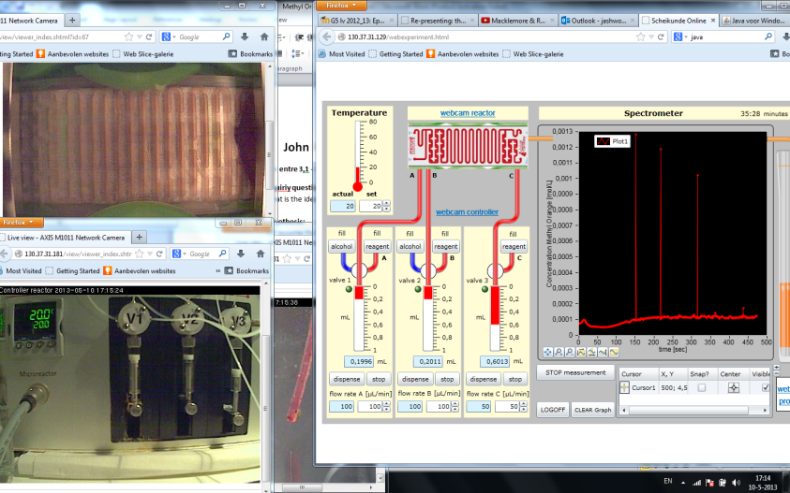
Introduction
Methyl Orange is a chemical product used for measuring changes in pH. Although very useful, it’s not known how to make Methyl Orange in its most efficient way. This article isn’t the first and definitely not the last, discussing this substance. For now, this inquiry merely plays a small part in a much larger development process.
Last year, Heanen, Harmelen and Oortwijn published an article about the ideal rate used in the production of Methyl Orange. They found that 100:100:50 gave the highest concentration. However, their group kept the temperature constant. We used the rate they found to find the ideal temperature for this particular rate (taking it even further).
Experimental procedure
This experiment was performed via a remote controlled micro-reactor. It dispenses a maximum of 1 ml to each of the three components and used in the production of Methyl Orange. A lot of data was already provided; each time we filled the dispense units with three different solutions:
Solution A;
- 16.7 mmol of sulfanic acid
- 16.7 mmol sodium carbonate
- 16.7 mmol sodium nitrate
- 166.7 mL water
- 83.4 mL ethanol, set to a flow rate of 100 ml/min.
Solution B;
- 3.16 mL N,N-dimethylaniline
- 6.3 mL 12 M HCl
- 238.7 mL water, also set to a flow rate of 100 ml/min.
Solution C;
- 18.8 mmol NaOH
- 62.5 mL water
- 187.5 mL ethanol, set to a flow rate of 100 ml/min. To clean, we filled the dispense units with alcohol and used a flow rate of 1500 to save time. We cleaned after every measurement was done and raised the temperature. Measurements were done at 20, 25, 30, 35, 40 and 45 degrees Celsius within two hours. The collected data was copied in an Excel file. Time was a minor problem; we could only reserve the micro reactor for 50 minutes. The 30 degrees measurement had to be run twice because we ran out of time the first time around, and didn’t get to save it.
Temperature (C°) | Average Concentration (M)
20  25 | 0,000214  0,000223
30 | 0,000350
35 | 0,000540
40 | 0,000800
45 | 0,000780
Results
In doing this web experiment; it was all about the results of course. Without these there would be neither an actual experiment nor any conclusion to be drawn from this. That’s why we felt we had to put the most focus on our results, in order to draw worthy yet appealing conclusions. In figure 1 below we can find the measurement number along the horizontal axis, and the concentration (M) along the ‘y’ axis. As seen in the legend, each colored line represents a different measurement temperature, with the total average shown in the grey line. Table 1 was necessary in order to achieve a more real representation; there you see the average of the concentration measurements listed.
[ table 1 ]
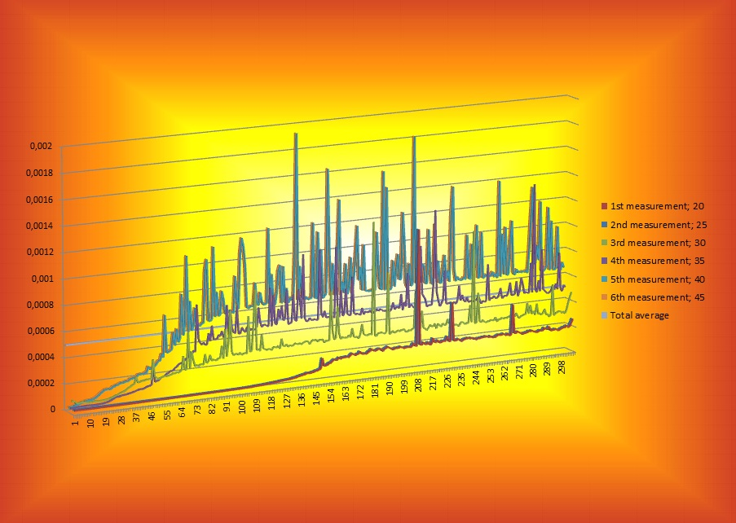
Inquiry question
What is the ideal temperature to produce methyl orange?
Hypothesis
We assume that the higher the temperature, the higher the concentration of methyl orange will be.
Based on which theory
The higher the temperature, the faster and more often particles collide which causes an increase of the likelihood of a chemical reaction.
Discussion
The results of this experiment aren’t absolute, though the results themselves are very accurate. The micro-reactor is extremely precise and since we worked with the average concentration, we were able to reduce the impact of the fault in the measurements, to a non-significant number.
We have only measured between 20 and 45 degrees Celsius, with 5 degree intervals. So there may be another, more ideal, temperature outside of our measured range, which is very likely.
Conclusion
Based on the results, we assume the ideal temperature isn’t its highest. Somewhere around 40 degrees Celsius should be a reasonably good estimate of where it’s at.

[ figure 1 ]

